Tugas 1 ERD

Nim : 3374152307030003

Nama : Yusril Arzaqi

Kelas : TK-P.21.2

Prodi : Tehnik Komputer

Latihan A – ERD Perpustakaan (yEd graph editor)

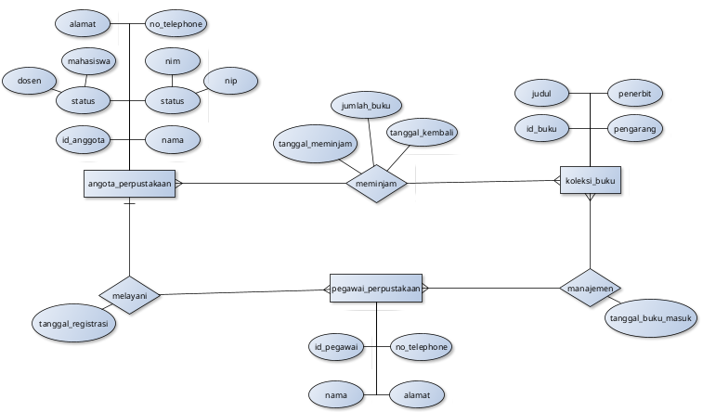

Latihan B – ERD CV.Sewo Car (yEd graph editor)

